Scientific Tools and Measurement
Day 10: Lesson Quiz
Choose the letter of the best answer.

1. Students compete in a short race at a track meet. Which of the following is an example of a qualitative observation?
A. the distance ran by a student in meters
B. the time passed from start to finish in seconds
C. the heart rate of a student in beats per second
D. the colors of the students’ faces as they ran
2. What property is a spring scale used to measure?
A. size of an object
B. mass of an object
C. flexibility of an object
D. weight of an object
3. Many tools can be used to measure the volume of a liquid. Which tool gives the most precise measurement of liquid volume?
A. beaker
B. test tube
C. measuring cup
D. graduated cylinder
4. The volume of regularly-shaped objects can be found by measuring each side and multiplying. The volume of a box can be calculated using the following equation:
V = l × w × h
V is volume, l is length, w is width, and h is height. Which of the tools shown below would be best suited to making these measurements?
A. 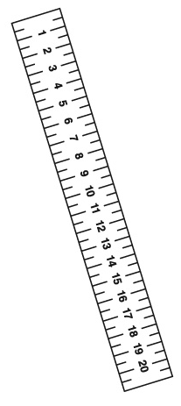 B. 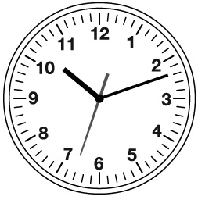
C. 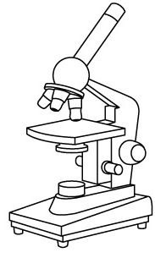 D. 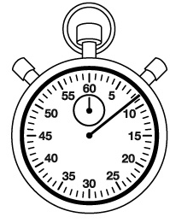
5. Rigby uses a pendulum to study oscillations.
He measures the amount of time it takes for the pendulum to complete a full swing. What would be the best way to record the time of the pendulum swing?
A. 3.5
B. 3.5 s
C. 0.0035 ks
D. 3500 ms

